**[SETTING UP APPLICATION ENVIRONMENT](https://careereducation.smartinternz.com/Student/guided_project_workspace/11261" \l "collapse2)**

CREATE FLASK PROJECT

1. Code:

app.py

from flask import Flask

app = Flask(_name_)

@app.route("/")

def hello():

return "Hello World!"

if _name_ == "_main_":

app.run()

1. Development

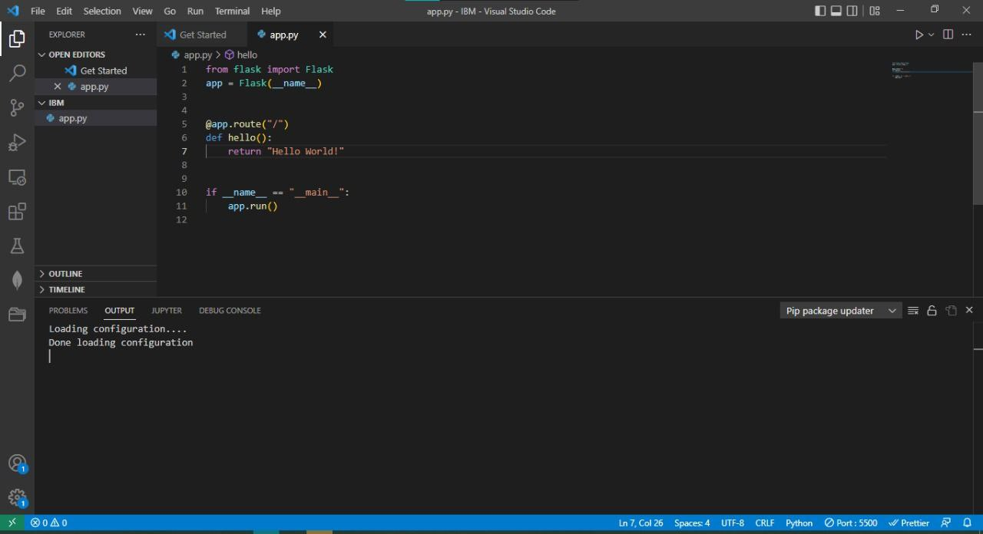

1. Running the server

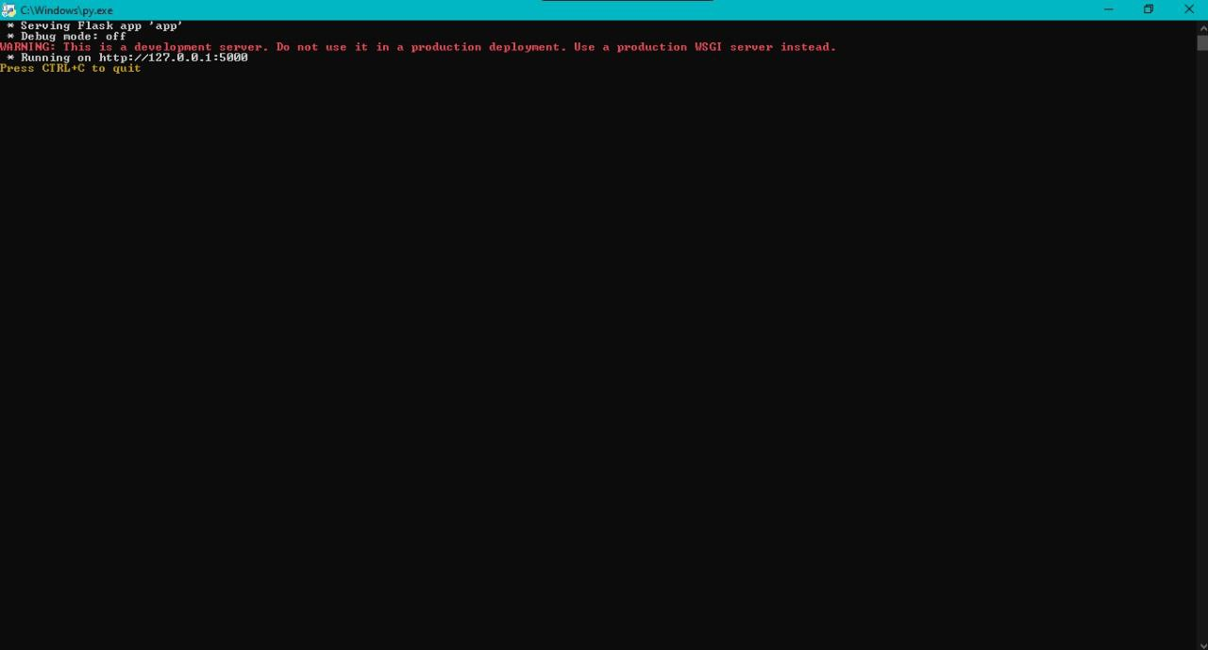

1. Website in localhost

